A Firm of Enrolled Agents

EA’s are required to pass a very stringent exam which requires thorough knowledge of tax laws and procedures. They must maintain 24 hours a year of continuing education including 2 hours of Ethics.

What does this mean to you? If you use an EA for tax advice and preparation, you can be assured you will receive professional service from a person with integrity and the technical expertise to apply the latest tax law revisions.

In addition to preparing tax returns, an EA can represent you before the IRS. Nothing is more intimidating than to receive a letter from the IRS in the mail. Before you respond to any correspondence with the IRS, we strongly encourage you to contact us. We can work with you to resolve IRS requests for overdue taxes, audits, collections and appeals. In most cases, you will not need to talk with, or meet with, agents from the IRS. We can be your advocate.

* * * * * * * * * * * *

If you have tax problems:

CALL AN ENROLLED AGENT
at Advanced Tax Centre, Inc.
ATC Tax Professionals

All ATC Tax Professionals are Graduate Fellows of the National Tax Practice Institute, the National Association of EA’s, the Florida Society of EA’s and the local Space Coast Chapter of EA’s.

Twila Denton Midwood, EA
Twila graduated from Rollins College in 1991 with a BS degree in Accounting. In 1998 she purchased Denton’s Bookkeeping from her father, Jim Denton, and in 2004 merged her business with ATC. She received her EA license in 2003. Twila is not only proficient in tax preparation and representation, but also manages the ATC bookkeeping department. Twila is the
2014/2015 President of the Florida Society of EA’s and was President of the Space Coast Chapter of EA’s from 2010 – 2012.

James A. Naff, EA
Jim has been in the tax preparation business for 38 years in Merritt Island and Rockledge. He received his Enrolled Agent license in 1977. He is well versed in corporate, estate, trust, and foreign tax issues. Jim has a background in banking and mortgage brokerage and is an expert in tax research. He is also a member of the National Society of Accountants.

E. Ann Shroll, EA
Ann has been a tax professional for 40 years. She received her EA license in 1976 in Ohio and had her own practice on Merritt Island. Ann has an Associate degree in Accounting and in Business Management from Brevard Community College. Ann prefers individual tax concerns and specializes in small businesses, rental properties and exchanges. She is Past President of both the Florida Society of EA’s and the National Association of EA’s. Ann was the Secretary of the Space Coast Chapter of EA’s from 2010-2012.

Edward Chambers, EA
Ed retired from the U. S. Army in 1986. He graduated from the University of Central Florida in 1989 with a BS degree in Accounting. He received his Enrolled Agent license in 1996 and has been active in the accounting and tax field for 28 years. Ed specializes in corporate and Partnership taxes, small business accounting, and
is proficient in QuickBooks and Excel. Ed was the 2013/2014 Treasurer of the Space Coast Chapter of EA’s.

ATC Professional Staff:

Tammy Yelton, Accounting Manager
Tammy is a full charge bookkeeper and has been the Accounting Manager since 2008. She is a graduate of the University of Central Florida with a Bachelor of Arts in Legal Studies. She also holds Associate degrees from Brevard Community College. Tammy has 18 years of bookkeeping and accounting experiences.

Christine Smith, Front Office
Christine joined Advanced Tax Centre, Inc. in January 2013. Whether greeting clients in the office or by phone, she is readily available to assist you with your needs. In addition, she handles administrative duties relative to the front office. Originally from upstate New York, Christine moved to Florida in 2001. She worked as an Administrative Coordinator for Publix in the Suntree area of Melbourne, Florida for 6 years prior to joining our group.

Advanced Tax Centre, Inc.
a full service tax and bookkeeping firm. We specialize in all types of tax services including the following:

IRS Representation:
IRS Correspondences
Audits
Collections
Appeals
Tax Preparation:
Individuals
Small Business, including Entity
Selection & Set-Up
Corporations
Partnerships
Estates and Trusts
Gift Tax
Small Exempt Organizations
Rentals
Sales
1031 Exchanges
Foreign Tax Exclusion
Clergy Tax

We also offer the following bookkeeping services:

Payroll Services
Quarterly & Annual Reports
Preparation of 1099’s and W-2’s
Sales Tax Reports
EFTPS and Online Filing
Bookkeeping and Write-Up
QuickBooks Set Up

Consultations available by appointment.

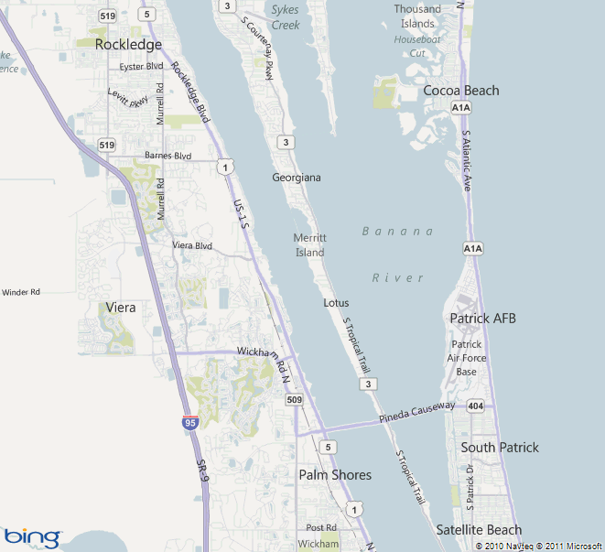

* * * * * * * * * * * *

ATC utilizes electronic filing for the benefit and convenience of our clients. We believe electronic filing reduces errors and loss of paperwork in the mail. Our goal is to be as efficient as possible and to utilize the latest technology in order to serve our clients.
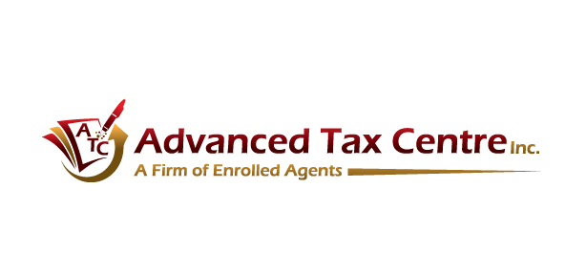
A Firm of Enrolled Agents
3819 Murrell Road, Suite E
Rockledge, FL 32955

Phone: (321) 636-8561
Fax: (321) 631-7208

E-mail: atc@advancedtaxcentre.com
Website: www.advancedtaxcentre.com

* * * * * * * * * * * *

All tax preparers of Advanced Tax Centre, Inc. are Enrolled Agents who are licensed by the U.S. Treasury to represent taxpayers before the IRS.

