LawTax: About Us
LawTax caters to all your accounting services that will meet your satisfaction because of our extensive knowledge, experience, and reliability. Accounting services are only fit for those who are trusted and have a solid reputation to back their name, LawTax is proud to claim that level of confidentiality with its customers. We accommodate individuals as well as businesses.
LawTax has been in this accounting services industry since 1999, and we have helped countless clients and business with their accounting needs. Our services are by no means limited and we want to offer you as many accounting services as possible. From bookkeeping to financial advising, we have everything for you. Our mission is to help our clients preserve their financial practicality all the while focusing on achieving future aims. We keep an interactive service with our clients, may they be individuals or businesses, so that all their requirements are met. It is this two-way approach with our customers that has allowed to get this far, which we owe our customers the credit to.
Primary Services
- Individual and business tax preparation services such as electronic filing, direct deposit, quick refund options
- Payroll
- Accounting
- Bookkeeping
- Financial consultation and planning
- Business startups and organization (incorporations and LLCs)
- A dedicated mobile app which allows users to upload their tax documents directly to the preparer and provide easy access to sign tax return
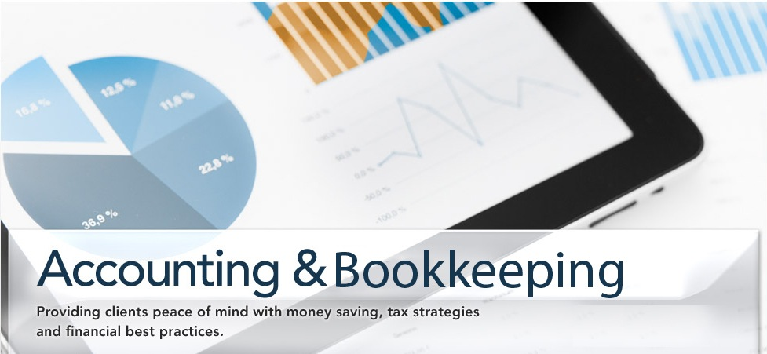
Apart from these primary services, we also offer financial conferences and classes for our clients. This enables us to forward our knowledge to you and help you know all there is to know about finances. We do not just want to be the accounting service of today but also help you create a stable plan for tomorrow. We figured everyone likes financial stability and potential growths, and the best way to help you achieve that is through our conferences and trainings.
We have a secure and safe network consisting of computers and firewalls to ensure that our customers are putting their accounting responsibilities on a name that is reliable and authentic. We value your trust and endeavor to provide you with the convenience you deserve.
Our accountants are the best in the field, with not only the right certificates and licenses but also with vast knowledge and expertise regarding accounting. Add that to their experience and you can find no better accounting service than LawTax. We know how much your accounting needs matter, and since you matter to us, your accounting needs are taken with great responsibility.
Why Us?
- Honest – Your financial needs come first and we endeavor to provide you back any money that the law allows.
- Well rounded – Our diverse background and well rounded team can be of great value in the course of your taxes, personal finance management or business.
- Trustworthy – We can be your trustworthy confidant whom you can confide even your most guarded personal financial information or any proprietary data. We handle all your financial matters with strict confidentiality and we make sure that we will handle them with the best care possible.
- Professional – It is only a professional service that will try to look out for its clients more than itself. We are that level of professionalism that values each and every client more than our own name.
- Secure – With LawTax, you can be sure that your financial matters are dealt with in a secure manner

