Have you looked at the cost of preparing your 2015 year-end Forms 1099 ?
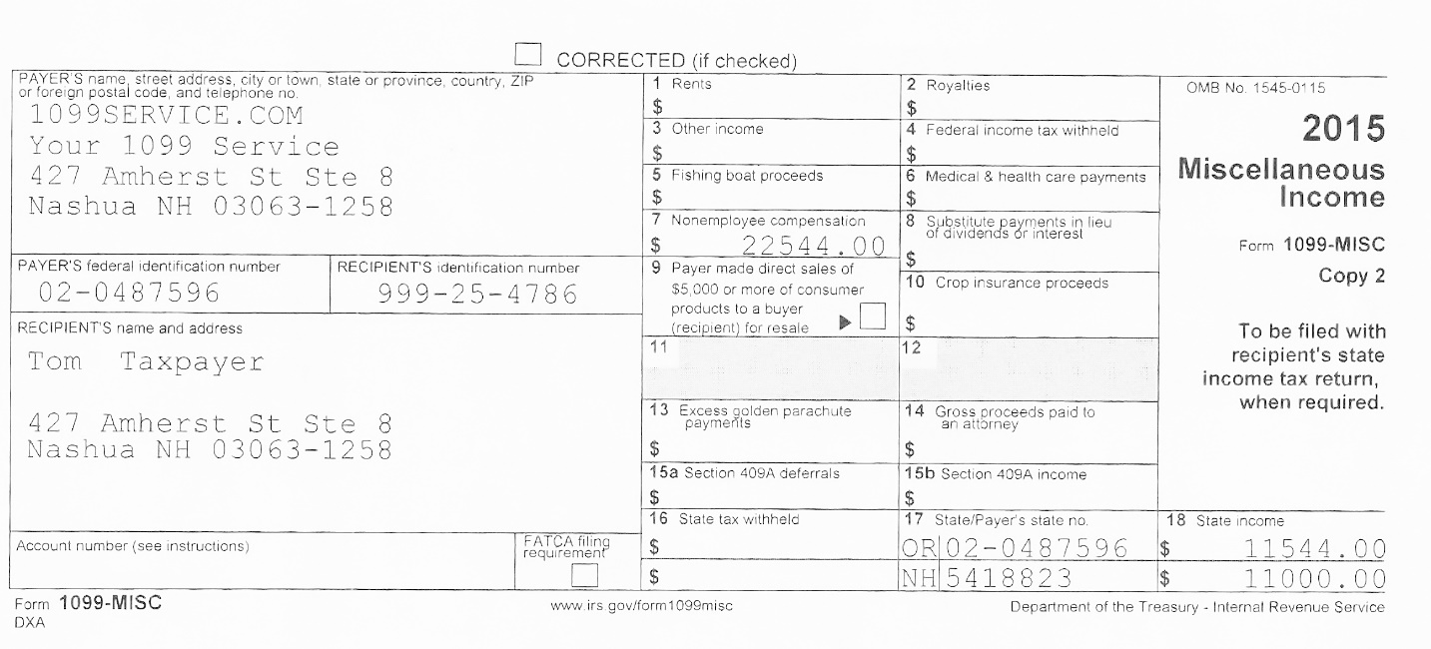
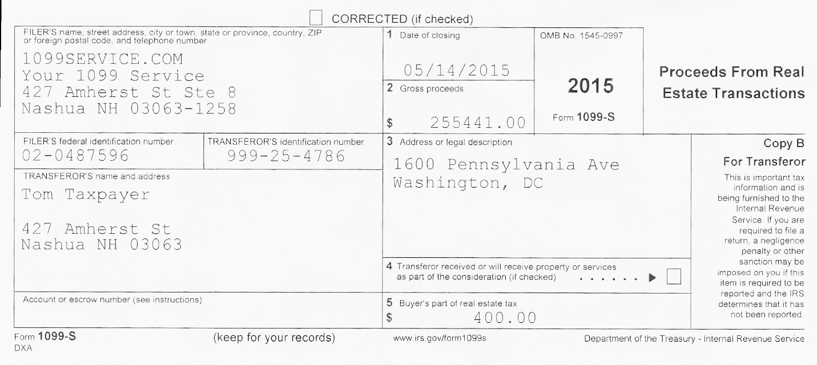
Software $ $ $
Learning curve $ $ $
Supplies $ $ $
Printer $ $ $
Employees time $ $ $
Folding / printing $ $ $
Stamping / mailing $ $ $

For 10 or fewer forms you can have McCobb Associates, LLP do all of the above for $45.00. Numbers greater than 10 the cost is $3.10 and from 100 on up the cost is $2.99 per form.
- We create the forms,
- We print and mail the forms to the recipient
- We electronically file your returns at the Internal Revenue
- We provide you with copies of the returns filed.

McCobb Associates, LLP INFO@1099SERVICE.net

603-889-3255

